Homework 8
- Write a function IsPrime(…) that has a single parameter x of type integer. If x is a prime number, the function returns 1; otherwise, the function returns 0
- Write a function EvalPoly(…)that expects four float parameters a, b, c, and x. The function should return the value ax² + bx + c.
- Write a function that rounds a number to a given number of decimal places(有效位數) and returns the rounded value as the function result.
x
Round
(四捨五入)

Round of (x)
places
(有效位數)

For example, the call Round (7.8257 , 2) would return the value 7.83.
Hint: To round a number to the nearest integer, add 0.5 and then truncate
the sum( discarding the fraction part 去掉小數部份)
Ex2:
Round (7.8257, 3)
7.826
782.57
+ .5
783.07
Ex1:
Round (7.8257, 2)
7.83

- (加分題, 可不寫, 但是同學儘量寫, 可互相討論)
A control system applies a force to an actuator (致動器) proportional to the voltage of a signal coming into the control system.
It is desired not to allow the actuator to quiver back and forth in the presence of small corrections near the zero-force point(若力太小,則忽略不計,以免actuator擺來擺去)

More force is required for the actuator to move to the left (negative direction of motion) than is required for motion to the right (positive direction motion).

Assume that the transfer function (the relationship between the voltage and the movement) of the actuator is

- Voltage less than –0.2 volt: Actuator moves 1 cm/volt in the negative direction.

- Absolute value of voltage less than or equal to 0.2 volt: No motion.

- Voltage great than 0.2 volt: Actuator moves 2 cm/volt in the positive
Direction.

Write a function force (…) to compute the total motion for any signal input
.
Write a main program that repeatedly calls the force ( …) function using
an input signal stream such as :

-10.0 v, –8.0 v, -0.21 v, -0.20 v, -0.05 v, 1.5 v, 0.00 v, 4.5 v,
10.0 v

The main program should also take as user input an initial position of the actuator and should output a final position resulting from applying the signals of the given control stream.
For one test, simulate the effect of the given voltages for an initial position of 1.5 cm to find the final position of the actuator.

- (加分題,可不寫)
Write a program that prints a calendar for a year. Prompt the user for the year and print the year and the calendar.
Hint1:
January 1 in year x begins on day:
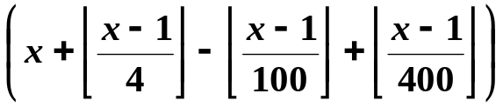 mod 7
(a).Where 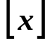 denotes the greatest integer less than or equal to x.
(b). M mod n denotes the remainder when m is divided by n.
(c). Sunday corresponds to 0, Monday to 1, and so on.

For example, if x = 1998,
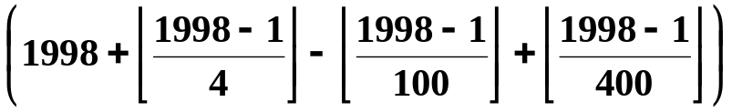 mod 7
= (1998 +499- 19 +4) mod 7 = 4
Thus, January 1, 1998 begins on Thursday.
Hint2: Year x is a leap year if
x is divisible by 4 and not by 100
or x is divisible by 400

For example:
(a).1998 is divisible by neither 4 nor 400. So 1998 is not a leap year.
(b).1996 is divisible by 4 and not by 100. So 1996 is a leap year.
(c).2000 is divisible by 400. So 2000 is a leap year.
(d).1990 is divisible by 4 and by 100, and is not divisible by 400.
So 1990 is not a leap year.

